BÖLÜM 2 MATLAB KODLARI
% MATLAB code bisection.m
%%%%%%%%%%%%%%%%%%%%%%%%%%%%%%%%%%%%%%%%%
%
% a -> lower bound of the design variable
% b -> upper bound of the design variable,
% alpha -> midpoint of a and b
% delx -> ?x for central difference method
% derivative -> derivative using central difference method
% derivative_alpha -> derivative at x = alpha
% abs -> absolute of a number, MATLAB function
%
clear all
clc
a = 40;
b = 90;
epsilon = 0.01;
delx = 0.01;
fprintf(' a b \n')
fprintf('-------------------------\n')
for i= 1:100
fprintf(' %7.3f %8.3f \n',a,b)
alpha = (a+b)/2;
derivative = (func(a+delx) - func(a-delx) )/(2*delx);
derivative_alpha = (func(alpha+delx)- func(alpha-delx))/(2*delx);
if (derivative*derivative_alpha) < 0
b = alpha;
else
a = alpha;
end
if abs(a-b) < epsilon
break;
end
end
fprintf('-------------------------\n')
fprintf('x* = %7.3f Minimum = %8.3f\n',a,func(a))
fprintf('Number of function calls = %3d\n',4*i)
%
Örnek: Bisection yöntemi f= f(x)=x2−4x+5
clc
clear
close all
% Fonksiyonun türevi
df = @(x) 2*x - 4;
% Başlangıç aralığı
x1 = 0;
x2 = 5;
% Tolerans
tol = 1e-6;
% Maksimum iterasyon
max_iter = 100;
% Başlangıç kontrolü
if df(x1)*df(x2) >= 0
error('Başlangıç aralığı uygun değil')
end
for k = 1:max_iter
% Orta nokta
xm = (x1 + x2)/2;
% Durma şartı
if abs(df(xm)) < tol || abs(x2-x1) < tol
break
end

% Aralık güncelle
if df(x1)*df(xm) < 0
x2 = xm;
else
x1 = xm;
end
end
xmin = xm;
iterasyon = k;
fprintf('Minimum noktasi x = %.6f\n', xmin);
fprintf('Iterasyon sayisi = %d\n', iterasyon);
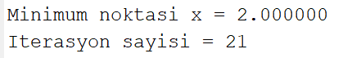olarak bulunur.
%%%%%%%%%%%%%%%%%%%%%%%%%%%%%%%%%%%%%%%%%
% Newton-Raphson Method for Minimization
clear
clc
func = @(x) (x-55).^2 + 100;
x = 45; % initial guess
delx = 0.01;
epsilon = 0.01;
fprintf(' x f(x) Deriv. Second deriv.\n')
fprintf('---------------------------------------------\n')
for i = 1:100
% First derivative (central difference)
derivative = (func(x+delx) - func(x-delx))/(2*delx);
% Second derivative
sec_derivative = ...
(func(x+delx)+func(x-delx)-2*func(x))/(delx^2);
fprintf('%8.3f %8.3f %8.3f %8.3f\n',...
x,func(x),derivative,sec_derivative)
xprev = x;
% Newton update
x = x - derivative/sec_derivative;
if abs(x-xprev) < epsilon
break
end
end
fprintf('---------------------------------------------\n')
fprintf('Minimum x* = %.4f\n',x)
fprintf('Number of function calls = %3d\n',5*i)
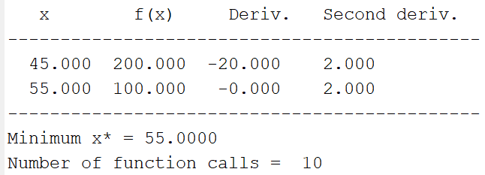
%%%%%%%%%%%%%%%%%%%%%%%%%%%%%%%%%%%%%%%%%
% SECANT METHOD FOR MINIMIZATION
%%%%%%%%%%%%%%%%%%%%%%%%%%%%%%%%%%%%%%%%%

clear
clc

% -------- Fonksiyon ----------
func = @(x) (x-55).^2 + 100;

% -------- Başlangıç aralığı ----------
a = 40;
b = 90;

epsilon = 0.001;
delx = 0.01;

fprintf(' Alpha Derivative\n')
fprintf('--------------------------------\n')

%% -------- Minimumu bracket et (Bisection kısmı) --------
for i = 1:100

alpha = (a+b)/2;

derivative_a = ...
(func(a+delx)-func(a-delx))/(2*delx);

derivative_alpha = ...
(func(alpha+delx)-func(alpha-delx))/(2*delx);

if derivative_a*derivative_alpha < 0
b = alpha;
break
else
a = alpha;
end
end
%%%% -------- Secant Iterasyonu ------%%%%%%%%%%%%%%%%--
for j = 1:100
derivative_a = ...
(func(a+delx)-func(a-delx))/(2*delx);
derivative_b = ...
(func(b+delx)-func(b-delx))/(2*delx);
% Secant formülü
alpha = b - derivative_b*(b-a) / ...
(derivative_b-derivative_a);
derivative_alpha = ...
(func(alpha+delx)-func(alpha-delx))/(2*delx);
fprintf('%10.4f %14.6f\n',alpha,derivative_alpha)
% Aralık güncelle
if derivative_alpha > 0
b = alpha;
else
a = alpha;
end

% Durma kriteri
if abs(derivative_alpha) < epsilon
break
end
end
fprintf('--------------------------------\n')
fprintf('Minimum noktasi x* = %.4f\n',alpha)
fprintf('Minimum degeri f(x*) = %.4f\n',func(alpha))
fprintf('Iterasyon sayisi = %d\n',j)
fprintf('Fonksiyon cagrisi ≈ %d\n',4*i+6*j)
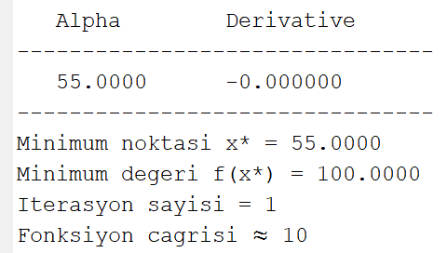
%%%%%%%%%%%%%%%%%%%%%%%%%%%%%%%%%%%%%%%%%
% CUBIC INTERPOLATION METHOD FOR MINIMIZATION
%%%%%%%%%%%%%%%%%%%%%%%%%%%%%%%%%%%%%%%%%

clear
clc

% -------- Fonksiyon ----------
func = @(x) (x-55).^2 + 100; % örnek fonksiyon

% -------- Başlangıç aralığı ----------
a = 40;
b = 90;
delx = 0.01;
epsilon = 0.001;
flag = 0;

fprintf(' Iteration: a b\n')
fprintf('-----------------------------\n')

%% -------- Minimumu bracket et --------
for i = 1:100
alpha = (a+b)/2;

derivative_a = (func(a+delx)-func(a-delx))/(2*delx);
derivative_alpha = (func(alpha+delx)-func(alpha-delx))/(2*delx);

if derivative_a*derivative_alpha < 0
b = alpha;
flag = 1;
else
a = alpha;
end
if flag == 1
break
end
end
%% -------- Cubic Interpolation Iterasyonu --------
for j = 1:100
derivative_a = (func(a+delx)-func(a-delx))/(2*delx);
derivative_b = (func(b+delx)-func(b-delx))/(2*delx);
% Cubic interpolation formülleri
z = 3*(func(a)-func(b))/(b-a) + derivative_a + derivative_b;
w = ((b-a)/abs(b-a))*sqrt(z^2 - derivative_a*derivative_b);
mew = (derivative_b + w - z)/(derivative_b - derivative_a + 2*w);
if mew <= 1
x_opt = b - mew*(b-a);
else
x_opt = a;
end
% Türev değeri
derivative_xopt = (func(x_opt+delx)-func(x_opt-delx))/(2*delx);
% Durma kriteri
if abs(derivative_xopt) < epsilon
break
else
if derivative_a*derivative_xopt < 0
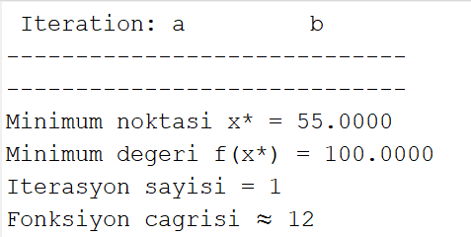
b = x_opt;
else
a = x_opt;
end
end
end
fprintf('-----------------------------\n')
fprintf('Minimum noktasi x* = %.4f\n', x_opt)
fprintf('Minimum degeri f(x*) = %.4f\n', func(x_opt))
fprintf('Iterasyon sayisi = %d\n', j)
fprintf('Fonksiyon cagrisi ≈ %d\n', 4*i + 8*j)
%%%%%%%%%%%%%%%%%%%%%%%%%%%%%%%%%%%%%%%%%
% GOLDEN SECTION SEARCH FOR MINIMIZATION
clear
clc
% -------- Fonksiyon ----------
func = @(x) (x-55).^2 + 100;
% -------- Başlangıç aralığı ----------
a = 40;
b = 90;
epsilon = 1e-5;
tau = 0.381967;
% İlk noktalar
alpha1 = a*(1-tau) + b*tau;
alpha2 = a*tau + b*(1-tau);
alpha1 = func(alpha1);
falpha2 = func(alpha2);
fprintf(' Iter a b\n')
fprintf('--------------------------------\n')
for i = 1:100
fprintf('%3d %10.5f %10.5f\n', i, a, b);
% Durma kriteri
if abs(b-a) < epsilon
break
end
if falpha1 > falpha2
a = alpha1;
alpha1 = alpha2;
falpha1 = falpha2;

alpha2 = tau*a + (1-tau)*b;
falpha2 = func(alpha2);
else
b = alpha2;
alpha2 = alpha1;
falpha2 = falpha1;
alpha1 = (1-tau)*a + tau*b;
falpha1 = func(alpha1);
end
end
% Minimum tahmini
x_opt = (a+b)/2;
f_opt = func(x_opt);

fprintf('--------------------------------\n')
fprintf('Minimum noktasi x* = %.5f\n',x_opt)
fprintf('Minimum degeri f(x*) = %.5f\n',f_opt)
fprintf('Iterasyon sayisi = %d\n',i)
fprintf('Fonksiyon cagrisi ≈ %d\n',2+i)
